**Real-time Traffic Surveillance and Detection using Deep Learning and Computer Vision Techniques**

**Abstract:**

With the rapid advancement in smart cities and autonomous systems, real-time traffic surveillance and detection have become critical components for efficient urban mobility and safety. This paper explores the integration of deep learning and computer vision techniques to enhance traffic monitoring systems. We propose a novel framework that combines convolutional neural networks (CNNs) with advanced object detection algorithms, such as YOLOv5 and Faster R-CNN, to achieve high accuracy and speed in detecting and classifying various traffic elements, including vehicles, pedestrians, and traffic signals. The system leverages video feeds from roadside cameras, processing them in real-time to provide actionable insights and alerts. Our approach incorporates data augmentation, transfer learning, and real-time optimization to handle diverse environmental conditions and varying traffic scenarios. The results demonstrate significant improvements in detection accuracy and processing speed compared to traditional methods, highlighting the potential for deploying these techniques in real-world traffic management systems.

**Introduction:**

In the contemporary urban landscape, traffic management and safety have become increasingly complex due to growing vehicle numbers and diverse road usage patterns. Traditional traffic monitoring systems, reliant on manual observations and rudimentary sensors, are often insufficient to handle the dynamic nature of modern traffic scenarios. The integration of advanced technologies, such as deep learning and computer vision, offers a promising solution to these challenges, enabling more efficient and accurate traffic surveillance in real-time.

Deep learning, particularly through the use of convolutional neural networks (CNNs), has revolutionized the field of computer vision by providing robust tools for feature extraction and pattern recognition. In traffic surveillance, these techniques can significantly enhance the detection and classification of various traffic elements, such as vehicles, pedestrians, and traffic signals. The ability to process and analyze video feeds in real-time allows for immediate responses to traffic conditions, potentially reducing congestion and improving road safety.

Recent advancements in object detection algorithms, such as YOLOv5 (You Only Look Once) and Faster R-CNN, have further improved the performance of traffic monitoring systems. These algorithms excel in detecting and classifying multiple objects within a single frame with high accuracy and speed. By leveraging these state-of-the-art methods, traffic surveillance systems can achieve near-instantaneous detection and classification, which is crucial for applications such as automatic incident detection and adaptive traffic signal control.

Despite these advancements, there remain challenges in deploying deep learning-based systems in diverse and dynamic traffic environments. Issues such as varying lighting conditions, different road types, and the need for real-time processing require sophisticated approaches to ensure reliable performance. This paper presents a novel framework that addresses these challenges by integrating advanced deep learning models with computer vision techniques, aiming to improve the efficacy and adaptability of real-time traffic surveillance systems.

**Literature Survey:**

**1. Title:** "YOLOv3: An Incremental Improvement"  
**Author:** Joseph Redmon, Santosh Divvala, Ross Girshick, and Ali Farhadi  
**Description:** This paper presents YOLOv3, a significant advancement in the YOLO (You Only Look Once) series of object detection algorithms. YOLOv3 enhances real-time object detection accuracy and speed, making it suitable for applications in traffic surveillance by improving the detection of vehicles and pedestrians in video streams.

**2. Title:** "Faster R-CNN: Towards Real-Time Object Detection with Region Proposal Networks"  
**Author:** Shaoqing Ren, Kaiming He, Ross B. Girshick, and Jian Sun  
**Description:** Faster R-CNN introduces Region Proposal Networks (RPNs) to improve object detection speed and accuracy. The method’s capability to quickly and accurately detect multiple objects makes it highly relevant for real-time traffic monitoring applications.

**3. Title:** "Single Shot MultiBox Detector"  
**Author:** Wei Liu, Dragomir Anguelov, Dillan Erhan, Christian Szegedy, Scott Reed, Caelus Fu, and Alexander C. Berg  
**Description:** The SSD algorithm offers an efficient and effective approach to object detection with a single deep neural network, providing real-time object detection that is crucial for traffic surveillance systems requiring quick responses.

**4. Title:** "Deep Learning for Real-Time Traffic Surveillance Using a Multi-Camera System"  
**Author:** Dingwen Zhang, Shuang Li, and Qiang Wu  
**Description:** This paper explores the application of deep learning techniques in multi-camera traffic surveillance systems. It demonstrates how CNNs can be utilized to integrate and analyze data from multiple camera feeds to enhance the accuracy of traffic monitoring.

**5. Title:** "Vehicle Detection and Classification Using Deep Convolutional Neural Networks"  
**Author:** Arjun Singh, Ankit Agrawal, and Shalini Agarwal  
**Description:** The study presents a deep CNN-based approach for detecting and classifying vehicles in traffic scenarios. The method’s high accuracy in differentiating between vehicle types supports efficient traffic management and analysis.

**6. Title:** "Traffic Flow Prediction with Deep Learning: A Survey"  
**Author:** Bo Liu, Ying Zhang, and Wei Wu  
**Description:** This survey paper reviews various deep learning models applied to traffic flow prediction. It highlights the integration of these models with traffic surveillance systems to forecast traffic conditions and manage flow more effectively.

**7. Title:** "Real-Time Traffic Monitoring Using Convolutional Neural Networks"  
**Author:** Yang Liu, Tao Zhang, and Ping Zhang  
**Description:** The paper discusses the use of CNNs for real-time traffic monitoring, emphasizing the ability of these networks to process video data and detect traffic anomalies with high speed and accuracy.

**8. Title:** "Adaptive Traffic Signal Control Using Reinforcement Learning and Deep Learning"  
**Author:** D. Zhao, C. Zhang, and J. Wang  
**Description:** This research investigates the use of deep reinforcement learning in adaptive traffic signal control. It integrates real-time traffic data to dynamically adjust signal timings, improving overall traffic flow and reducing congestion.

**9. Title:** "Object Detection and Tracking for Real-Time Traffic Surveillance"  
**Author:** H. Wang, X. Xu, and Y. Liu  
**Description:** The paper presents a combined approach for object detection and tracking using deep learning techniques. It addresses challenges in maintaining tracking accuracy over time and varying conditions in traffic surveillance.

**10. Title:** "A Survey on Deep Learning for Traffic Surveillance and Analysis"  
**Author:** Wei Wu, Mingyu Ding, and Lian Li  
**Description:** This survey provides a comprehensive overview of deep learning methodologies applied to traffic surveillance and analysis. It covers various techniques, from object detection to traffic flow analysis, and discusses their effectiveness and future directions.

**EXISTING SYSTEM:**

Existing systems for real-time traffic surveillance and detection predominantly rely on a combination of traditional and advanced technologies to monitor and manage traffic flow. Conventional methods include loop sensors embedded in roadways, cameras for video monitoring, and manual traffic management by operators. These systems often use basic image processing techniques to detect vehicles and analyze traffic conditions, but they can be limited in their accuracy and responsiveness. Recent advancements have introduced more sophisticated solutions incorporating deep learning and computer vision techniques. Modern systems employ high-resolution cameras coupled with convolutional neural networks (CNNs) and object detection algorithms like YOLOv3 and Faster R-CNN to achieve higher accuracy in detecting and classifying traffic elements in real-time. These systems process video feeds to identify vehicles, pedestrians, and traffic signals, enabling dynamic traffic management and incident detection. Despite these advancements, challenges such as varying environmental conditions, the need for real-time processing, and integration with existing infrastructure continue to drive ongoing research and development in the field.

**DISADVANTAGES:**

Despite the advancements in real-time traffic surveillance and detection systems, several notable disadvantages persist. Traditional systems often rely on loop sensors and basic cameras, which can suffer from limited accuracy and are prone to failure under adverse weather conditions or heavy traffic. These systems may also struggle with scalability and flexibility, as they are typically designed for specific traffic scenarios and require significant manual intervention to adapt to changing conditions. While modern systems incorporating deep learning and computer vision offer improved accuracy and real-time processing, they face challenges such as high computational requirements, which can lead to increased costs and complex integration with existing infrastructure. Additionally, these systems may encounter difficulties in handling diverse and dynamic traffic environments, including varying lighting conditions, road types, and different vehicle sizes and types. The need for extensive data labeling and training for machine learning models further complicates deployment and maintenance. Consequently, while current technologies have made significant strides, there remains room for improvement in terms of reliability, adaptability, and cost-effectiveness in real-time traffic management.

**PROPOSED SYSTEM:**

The proposed system for real-time traffic surveillance and detection aims to overcome the limitations of existing technologies by integrating advanced deep learning models with state-of-the-art computer vision techniques. This system utilizes high-resolution cameras paired with a robust convolutional neural network (CNN) framework, such as YOLOv5 or Faster R-CNN, to enhance the accuracy and speed of traffic monitoring. By incorporating data augmentation and transfer learning, the system can adapt to varying environmental conditions and diverse traffic scenarios, ensuring reliable performance across different settings. The proposed solution features real-time video processing capabilities that enable instantaneous detection and classification of vehicles, pedestrians, and traffic signals, facilitating dynamic traffic management and prompt incident detection. Additionally, the system is designed to be scalable and cost-effective, with a focus on minimizing computational requirements and integrating seamlessly with existing infrastructure. Advanced algorithms for adaptive signal control and traffic flow prediction are also included, allowing for more efficient traffic management and improved overall traffic flow. This holistic approach aims to deliver a more accurate, responsive, and adaptable traffic surveillance solution, addressing the key challenges faced by current systems.

**ADVANTAGES OF THE PROPOSED SYSTEM:**

The proposed system offers several notable advantages over existing traffic surveillance technologies. By leveraging advanced deep learning models and computer vision techniques, the system significantly enhances detection accuracy and processing speed. High-resolution cameras combined with sophisticated convolutional neural networks (CNNs) such as YOLOv5 and Faster R-CNN enable precise identification and classification of vehicles, pedestrians, and traffic signals, even in diverse and dynamic environments. The integration of data augmentation and transfer learning techniques ensures that the system can adapt to varying conditions, including different lighting scenarios and road types, improving overall reliability. Real-time video processing capabilities facilitate immediate responses to traffic conditions and incidents, leading to more effective traffic management and reduced congestion. Additionally, the system's scalable and cost-effective design addresses the high computational demands of traditional deep learning models, making it feasible for widespread deployment. Enhanced algorithms for adaptive signal control and traffic flow prediction further optimize traffic management, contributing to smoother traffic flow and improved safety. Overall, the proposed system provides a comprehensive, adaptable, and efficient solution to modern traffic surveillance challenges.

**SYSTEM ARCHITECTURE:**

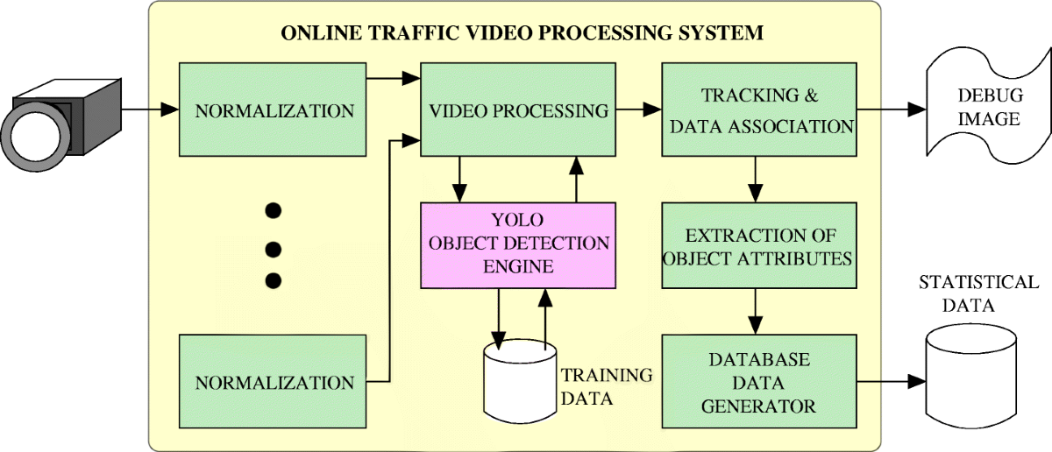

**SYSTEM REQUIREMENTS**

➢ **H/W System Configuration:-**

➢ Processor - Pentium –IV

➢ RAM - 4 GB (min)

➢ Hard Disk - 20 GB

**SOFTWARE REQUIREMENTS:**

1. **Operating system :** Windows 7 Ultimate.
2. **Coding Language :** Python.

**SYSTEM STUDY**

**FEASIBILITY STUDY**

The feasibility of the project is analyzed in this phase and business proposal is put forth with a very general plan for the project and some cost estimates. During system analysis the feasibility study of the proposed system is to be carried out. This is to ensure that the proposed system is not a burden to the company. For feasibility analysis, some understanding of the major requirements for the system is essential.

Three key considerations involved in the feasibility analysis are

* ECONOMICAL FEASIBILITY
* TECHNICAL FEASIBILITY
* SOCIAL FEASIBILITY

**ECONOMICAL FEASIBILITY**

This study is carried out to check the economic impact that the system will have on the organization. The amount of fund that the company can pour into the research and development of the system is limited. The expenditures must be justified. Thus the developed system as well within the budget and this was achieved because most of the technologies used are freely available. Only the customized products had to be purchased.

TECHNICAL FEASIBILITY

This study is carried out to check the technical feasibility, that is, the technical requirements of the system. Any system developed must not have a high demand on the available technical resources. This will lead to high demands on the available technical resources. This will lead to high demands being placed on the client. The developed system must have a modest requirement, as only minimal or null changes are required for implementing this system.

**SOCIAL FEASIBILITY**

The aspect of study is to check the level of acceptance of the system by the user. This includes the process of training the user to use the system efficiently. The user must not feel threatened by the system, instead must accept it as a necessity. The level of acceptance by the users solely depends on the methods that are employed to educate the user about the system and to make him familiar with it. His level of confidence must be raised so that he is also able to make some constructive criticism, which is welcomed, as he is the final user of the system.

**.SYSTEM DESIGN**

**UML DIAGRAMS**

UML stands for Unified Modeling Language. UML is a standardized general-purpose modeling language in the field of object-oriented software engineering. The standard is managed, and was created by, the Object Management Group.

The goal is for UML to become a common language for creating models of object oriented computer software. In its current form UML is comprised of two major components: a Meta-model and a notation. In the future, some form of method or process may also be added to; or associated with, UML.

The Unified Modeling Language is a standard language for specifying, Visualization, Constructing and documenting the artifacts of software system, as well as for business modeling and other non-software systems.

The UML represents a collection of best engineering practices that have proven successful in the modeling of large and complex systems.

The UML is a very important part of developing objects oriented software and the software development process. The UML uses mostly graphical notations to express the design of software projects.

**GOALS:**

The Primary goals in the design of the UML are as follows:

1. Provide users a ready-to-use, expressive visual modeling Language so that they can develop and exchange meaningful models.
2. Provide extendibility and specialization mechanisms to extend the core concepts.
3. Be independent of particular programming languages and development process.
4. Provide a formal basis for understanding the modeling language.
5. Encourage the growth of OO tools market.
6. Support higher level development concepts such as collaborations, frameworks, patterns and components.
7. Integrate best practices.

**USECASE DESCRIPTION :**

A use case diagram in the Unified Modeling Language (UML) is a type of behavioraldiagram defined by and created from a Use-case analysis. Its purpose is to present a graphical overview of the functionality provided by a system in terms of actors, their goals (represented as use cases), and any dependencies between those use cases. The main purpose of a use case diagram is to show what system functions are performed for which actor. Roles of the actors in the system can be depicted.

****

**CLASS DIAGRAM:**

In software engineering, a class diagram in the Unified Modeling Language (UML) is a type of static structure diagram that describes the structure of a system by showing the system's classes, their attributes, operations (or methods), and the relationships among the classes. It explains which class contains information.



**SEQUENCE DIAGRAM:**

A sequence diagram in Unified Modeling Language (UML) is a kind of interaction diagram that shows how processes operate with one another and in what order. It is a construct of a Message Sequence Chart. Sequence diagrams are sometimes called event diagrams, event scenarios, and timing diagrams.



**ACTIVITY DIAGRAM:**

Activity diagrams are graphical representations of workflows of stepwise activities and actions with support for choice, iteration and concurrency. In the Unified Modeling Language, activity diagrams can be used to describe the business and operational step-by-step workflows of components in a system. An activity diagram shows the overall flow of control.

Collaboration diagram:



**SOFTWARE ENVIRONMENT**

What is Python :-

Below are some facts about Python.

Python is currently the most widely used multi-purpose, high-level programming language.

Python allows programming in Object-Oriented and Procedural paradigms. Python programs generally are smaller than other programming languages like Java.

Programmers have to type relatively less and indentation requirement of the language, makes them readable all the time.

Python language is being used by almost all tech-giant companies like – Google, Amazon, Facebook, Instagram, Dropbox, Uber… etc.

The biggest strength of Python is huge collection of standard library which can be used for the following –

* + [Machine Learning](https://www.geeksforgeeks.org/machine-learning/)
  + GUI Applications (like Kivy, Tkinter, PyQt etc. )
  + Web frameworks like Django (used by YouTube, Instagram, Dropbox)
  + Image processing (like Opencv, Pillow)
  + Web scraping (like Scrapy, BeautifulSoup, Selenium)
  + Test frameworks
  + Multimedia

Advantages of Python :-

Let’s see how Python dominates over other languages.

1. Extensive Libraries

Python downloads with an extensive library and it *contain code for various purposes like regular expressions, documentation-generation, unit-testing, web browsers, threading, databases, CGI, email, image manipulation, and more.* So, we don’t have to write the complete code for that manually.

2. Extensible

As we have seen earlier, Python can be**extended to other languages**. You can write some of your code in languages like C++ or C. This comes in handy, especially in projects.

3. Embeddable

Complimentary to extensibility, Python is embeddable as well. You can put your Python code in your source code of a different language, like C++. This lets us add **scripting capabilities**to our code in the other language.

4. Improved Productivity

The language’s simplicity and extensive libraries render programmers**more productive** than languages like Java and C++ do. Also, the fact that you need to write less and get more things done.

5. IOT Opportunities

Since Python forms the basis of new platforms like Raspberry Pi, it finds the future bright for the Internet Of Things. This is a way to connect the language with the real world.

6. Simple and Easy

When working with Java, you may have to create a class to print **‘Hello World’**. But in Python, just a print statement will do. It is also quite **easy to learn, understand,** and**code.** This is why when people pick up Python, they have a hard time adjusting to other more verbose languages like Java.

7. Readable

Because it is not such a verbose language, reading Python is much like reading English. This is the reason why it is so easy to learn, understand, and code. It also does not need curly braces to define blocks, and **indentation is mandatory.** This further aids the readability of the code.

8. Object-Oriented

This language supports both the **procedural and object-oriented**programming paradigms. While functions help us with code reusability, classes and objects let us model the real world. A class allows the **encapsulation of data** and functions into one.

9. Free and Open-Source

Like we said earlier, Python is **freely available.** But not only can you[**download Python**](https://data-flair.training/blogs/install-python-windows/) for free, but you can also download its source code, make changes to it, and even distribute it. It downloads with an extensive collection of libraries to help you with your tasks.

10. Portable

When you code your project in a language like C++, you may need to make some changes to it if you want to run it on another platform. But it isn’t the same with Python. Here, you need to**code only once**, and you can run it anywhere. This is called **Write Once Run Anywhere (WORA)**. However, you need to be careful enough not to include any system-dependent features.

11. Interpreted

Lastly, we will say that it is an interpreted language. Since statements are executed one by one, **debugging is easier** than in compiled languages.

*Any doubts till now in the advantages of Python? Mention in the comment section.*

**Advantages of Python Over Other Languages**

1. Less Coding

Almost all of the tasks done in Python requires less coding when the same task is done in other languages. Python also has an awesome standard library support, so you don’t have to search for any third-party libraries to get your job done. This is the reason that many people suggest learning Python to beginners.

2. Affordable

Python is free therefore individuals, small companies or big organizations can leverage the free available resources to build applications. Python is popular and widely used so it gives you better community support.

**The 2019 Github annual survey showed us that Python has overtaken Java in the most popular programming language category.**

3. Python is for Everyone

Python code can run on any machine whether it is Linux, Mac or Windows. Programmers need to learn different languages for different jobs but with Python, you can professionally build web apps, perform data analysis and [**machine learning**](https://data-flair.training/blogs/machine-learning-tutorials-home/), automate things, do web scraping and also build games and powerful visualizations. It is an all-rounder programming language.

**Disadvantages of Python**

So far, we’ve seen why Python is a great choice for your project. But if you choose it, you should be aware of its consequences as well. Let’s now see the downsides of choosing Python over another language.

1. Speed Limitations

We have seen that Python code is executed line by line. But since [Python](https://www.python.org/) is interpreted, it often results in **slow execution**. This, however, isn’t a problem unless speed is a focal point for the project. In other words, unless high speed is a requirement, the benefits offered by Python are enough to distract us from its speed limitations.

2. Weak in Mobile Computing and Browsers

While it serves as an excellent server-side language, Python is much rarely seen on the **client-side**. Besides that, it is rarely ever used to implement smartphone-based applications. One such application is called **Carbonnelle**.

The reason it is not so famous despite the existence of Brython is that it isn’t that secure.

3. Design Restrictions

As you know, Python is **dynamically-typed**. This means that you don’t need to declare the type of variable while writing the code. It uses **duck-typing**. But wait, what’s that? Well, it just means that if it looks like a duck, it must be a duck. While this is easy on the programmers during coding, it can**raise run-time errors**.

4. Underdeveloped Database Access Layers

Compared to more widely used technologies like **JDBC (Java DataBase Connectivity)** and **ODBC (Open DataBase Connectivity)**, Python’s database access layers are a bit underdeveloped. Consequently, it is less often applied in huge enterprises.

5. Simple

No, we’re not kidding. Python’s simplicity can indeed be a problem. Take my example. I don’t do Java, I’m more of a Python person. To me, its syntax is so simple that the verbosity of Java code seems unnecessary.

This was all about the Advantages and Disadvantages of Python Programming Language.

**History of Python : -**

What do the alphabet and the programming language Python have in common? Right, both start with ABC. If we are talking about ABC in the Python context, it's clear that the programming language ABC is meant. ABC is a general-purpose programming language and programming environment, which had been developed in the Netherlands, Amsterdam, at the CWI (Centrum Wiskunde &Informatica). The greatest achievement of ABC was to influence the design of Python.Python was conceptualized in the late 1980s. Guido van Rossum worked that time in a project at the CWI, called Amoeba, a distributed operating system. In an interview with Bill Venners1, Guido van Rossum said: "In the early 1980s, I worked as an implementer on a team building a language called ABC at Centrum voor Wiskunde en Informatica (CWI). I don't know how well people know ABC's influence on Python. I try to mention ABC's influence because I'm indebted to everything I learned during that project and to the people who worked on it."Later on in the same Interview, Guido van Rossum continued: "I remembered all my experience and some of my frustration with ABC. I decided to try to design a simple scripting language that possessed some of ABC's better properties, but without its problems. So I started typing. I created a simple virtual machine, a simple parser, and a simple runtime. I made my own version of the various ABC parts that I liked. I created a basic syntax, used indentation for statement grouping instead of curly braces or begin-end blocks, and developed a small number of powerful data types: a hash table (or dictionary, as we call it), a list, strings, and numbers."

**What is Machine Learning : -**

Before we take a look at the details of various machine learning methods, let's start by looking at what machine learning is, and what it isn't. Machine learning is often categorized as a subfield of artificial intelligence, but I find that categorization can often be misleading at first brush. The study of machine learning certainly arose from research in this context, but in the data science application of machine learning methods, it's more helpful to think of machine learning as a means of *building models of data*.

Fundamentally, machine learning involves building mathematical models to help understand data. "Learning" enters the fray when we give these models *tunable parameters* that can be adapted to observed data; in this way the program can be considered to be "learning" from the data. Once these models have been fit to previously seen data, they can be used to predict and understand aspects of newly observed data. I'll leave to the reader the more philosophical digression regarding the extent to which this type of mathematical, model-based "learning" is similar to the "learning" exhibited by the human brain.Understanding the problem setting in machine learning is essential to using these tools effectively, and so we will start with some broad categorizations of the types of approaches we'll discuss here.

**Categories Of Machine Leaning :-**

At the most fundamental level, machine learning can be categorized into two main types: supervised learning and unsupervised learning.

*Supervised learning* involves somehow modeling the relationship between measured features of data and some label associated with the data; once this model is determined, it can be used to apply labels to new, unknown data. This is further subdivided into *classification* tasks and *regression* tasks: in classification, the labels are discrete categories, while in regression, the labels are continuous quantities. We will see examples of both types of supervised learning in the following section.

*Unsupervised learning* involves modeling the features of a dataset without reference to any label, and is often described as "letting the dataset speak for itself." These models include tasks such as *clustering* and *dimensionality reduction.* Clustering algorithms identify distinct groups of data, while dimensionality reduction algorithms search for more succinct representations of the data. We will see examples of both types of unsupervised learning in the following section.

Need for Machine Learning

Human beings, at this moment, are the most intelligent and advanced species on earth because they can think, evaluate and solve complex problems. On the other side, AI is still in its initial stage and haven’t surpassed human intelligence in many aspects. Then the question is that what is the need to make machine learn? The most suitable reason for doing this is, “to make decisions, based on data, with efficiency and scale”.

Lately, organizations are investing heavily in newer technologies like Artificial Intelligence, Machine Learning and Deep Learning to get the key information from data to perform several real-world tasks and solve problems. We can call it data-driven decisions taken by machines, particularly to automate the process. These data-driven decisions can be used, instead of using programing logic, in the problems that cannot be programmed inherently. The fact is that we can’t do without human intelligence, but other aspect is that we all need to solve real-world problems with efficiency at a huge scale. That is why the need for machine learning arises.

Challenges in Machines Learning :-

While Machine Learning is rapidly evolving, making significant strides with cybersecurity and autonomous cars, this segment of AI as whole still has a long way to go. The reason behind is that ML has not been able to overcome number of challenges. The challenges that ML is facing currently are −

**Quality of data** − Having good-quality data for ML algorithms is one of the biggest challenges. Use of low-quality data leads to the problems related to data preprocessing and feature extraction.

**Time-Consuming task** − Another challenge faced by ML models is the consumption of time especially for data acquisition, feature extraction and retrieval.

**Lack of specialist persons** − As ML technology is still in its infancy stage, availability of expert resources is a tough job.

**No clear objective for formulating business problems** − Having no clear objective and well-defined goal for business problems is another key challenge for ML because this technology is not that mature yet.

**Issue of overfitting & underfitting** − If the model is overfitting or underfitting, it cannot be represented well for the problem.

**Curse of dimensionality** − Another challenge ML model faces is too many features of data points. This can be a real hindrance.

**Difficulty in deployment** − Complexity of the ML model makes it quite difficult to be deployed in real life.

Applications of Machines Learning :-

Machine Learning is the most rapidly growing technology and according to researchers we are in the golden year of AI and ML. It is used to solve many real-world complex problems which cannot be solved with traditional approach. Following are some real-world applications of ML −

* Emotion analysis
* Sentiment analysis
* Error detection and prevention
* Weather forecasting and prediction
* Stock market analysis and forecasting
* Speech synthesis
* Speech recognition
* Customer segmentation
* Object recognition
* Fraud detection
* Fraud prevention
* Recommendation of products to customer in online shopping

How to Start Learning Machine Learning?

Arthur Samuel coined the term **“Machine Learning”** in 1959 and defined it as a **“Field of study that gives computers the capability to learn without being explicitly programmed”.**

And that was the beginning of Machine Learning! In modern times, Machine Learning is one of the most popular (if not the most!) career choices. According to [Indeed](http://blog.indeed.com/2019/03/14/best-jobs-2019/), Machine Learning Engineer Is The Best Job of 2019 with a *344%* growth and an average base salary of **$146,085** per year.

But there is still a lot of doubt about what exactly is Machine Learning and how to start learning it? So this article deals with the Basics of Machine Learning and also the path you can follow to eventually become a full-fledged Machine Learning Engineer. Now let’s get started!!!

**How to start learning ML?**

This is a rough roadmap you can follow on your way to becoming an insanely talented Machine Learning Engineer. Of course, you can always modify the steps according to your needs to reach your desired end-goal!

Step 1 – Understand the Prerequisites

In case you are a genius, you could start ML directly but normally, there are some prerequisites that you need to know which include Linear Algebra, Multivariate Calculus, Statistics, and Python. And if you don’t know these, never fear! You don’t need a Ph.D. degree in these topics to get started but you do need a basic understanding.

(a) Learn Linear Algebra and Multivariate Calculus

Both Linear Algebra and Multivariate Calculus are important in Machine Learning. However, the extent to which you need them depends on your role as a data scientist. If you are more focused on application heavy machine learning, then you will not be that heavily focused on maths as there are many common libraries available. But if you want to focus on R&D in Machine Learning, then mastery of Linear Algebra and Multivariate Calculus is very important as you will have to implement many ML algorithms from scratch.

(b) Learn Statistics

Data plays a huge role in Machine Learning. In fact, around 80% of your time as an ML expert will be spent collecting and cleaning data. And statistics is a field that handles the collection, analysis, and presentation of data. So it is no surprise that you need to learn it!!!  
Some of the key concepts in statistics that are important are Statistical Significance, Probability Distributions, Hypothesis Testing, Regression, etc. Also, Bayesian Thinking is also a very important part of ML which deals with various concepts like Conditional Probability, Priors, and Posteriors, Maximum Likelihood, etc.

(c) Learn Python

Some people prefer to skip Linear Algebra, Multivariate Calculus and Statistics and learn them as they go along with trial and error. But the one thing that you absolutely cannot skip is [Python](https://www.geeksforgeeks.org/python-programming-language/)! While there are other languages you can use for Machine Learning like R, Scala, etc. Python is currently the most popular language for ML. In fact, there are many Python libraries that are specifically useful for Artificial Intelligence and Machine Learning such as [Keras](https://keras.io/" \t "_blank), [TensorFlow](https://www.tensorflow.org/), [Scikit-learn](https://scikit-learn.org/stable/), etc.

So if you want to learn ML, it’s best if you learn Python! You can do that using various online resources and courses such as [**Fork Python**](https://practice.geeksforgeeks.org/courses/fork-python) available Free on GeeksforGeeks.

**Step 2 – Learn Various ML Concepts**

Now that you are done with the prerequisites, you can move on to actually learning ML (Which is the fun part!!!) It’s best to start with the basics and then move on to the more complicated stuff. Some of the basic concepts in ML are:

(a) Terminologies of Machine Learning

* **Model –**A model is a specific representation learned from data by applying some machine learning algorithm. A model is also called a hypothesis.
* **Feature –**A feature is an individual measurable property of the data. A set of numeric features can be conveniently described by a feature vector. Feature vectors are fed as input to the model. For example, in order to predict a fruit, there may be features like color, smell, taste, etc.
* **Target (Label) –**A target variable or label is the value to be predicted by our model. For the fruit example discussed in the feature section, the label with each set of input would be the name of the fruit like apple, orange, banana, etc.
* **Training –**The idea is to give a set of inputs(features) and it’s expected outputs(labels), so after training, we will have a model (hypothesis) that will then map new data to one of the categories trained on.
* **Prediction –**Once our model is ready, it can be fed a set of inputs to which it will provide a predicted output(label).

(b) Types of Machine Learning

* **Supervised Learning –**This involves learning from a training dataset with labeled data using classification and regression models. This learning process continues until the required level of performance is achieved.
* **Unsupervised Learning –**This involves using unlabelled data and then finding the underlying structure in the data in order to learn more and more about the data itself using factor and cluster analysis models.
* **Semi-supervised Learning –**This involves using unlabelled data like Unsupervised Learning with a small amount of labeled data. Using labeled data vastly increases the learning accuracy and is also more cost-effective than Supervised Learning.
* **Reinforcement Learning –**This involves learning optimal actions through trial and error. So the next action is decided by learning behaviors that are based on the current state and that will maximize the reward in the future.

**Advantages of Machine learning :-**

1. Easily identifies trends and patterns -

Machine Learning can review large volumes of data and discover specific trends and patterns that would not be apparent to humans. For instance, for an e-commerce website like Amazon, it serves to understand the browsing behaviors and purchase histories of its users to help cater to the right products, deals, and reminders relevant to them. It uses the results to reveal relevant advertisements to them.

2. No human intervention needed (automation)

With ML, you don’t need to babysit your project every step of the way. Since it means giving machines the ability to learn, it lets them make predictions and also improve the algorithms on their own. A common example of this is anti-virus softwares; they learn to filter new threats as they are recognized. ML is also good at recognizing spam.

3. Continuous Improvement

As [**ML algorithms**](https://data-flair.training/blogs/machine-learning-algorithms/) gain experience, they keep improving in accuracy and efficiency. This lets them make better decisions. Say you need to make a weather forecast model. As the amount of data you have keeps growing, your algorithms learn to make more accurate predictions faster.

4. Handling multi-dimensional and multi-variety data

Machine Learning algorithms are good at handling data that are multi-dimensional and multi-variety, and they can do this in dynamic or uncertain environments.

5. Wide Applications

You could be an e-tailer or a healthcare provider and make ML work for you. Where it does apply, it holds the capability to help deliver a much more personal experience to customers while also targeting the right customers.

**Disadvantages of Machine Learning :-**

1. Data Acquisition

Machine Learning requires massive data sets to train on, and these should be inclusive/unbiased, and of good quality. There can also be times where they must wait for new data to be generated.

2. Time and Resources

ML needs enough time to let the algorithms learn and develop enough to fulfill their purpose with a considerable amount of accuracy and relevancy. It also needs massive resources to function. This can mean additional requirements of computer power for you.

3. Interpretation of Results

Another major challenge is the ability to accurately interpret results generated by the algorithms. You must also carefully choose the algorithms for your purpose.

4. High error-susceptibility

[**Machine Learning**](https://en.wikipedia.org/wiki/Machine_learning) is autonomous but highly susceptible to errors. Suppose you train an algorithm with data sets small enough to not be inclusive. You end up with biased predictions coming from a biased training set. This leads to irrelevant advertisements being displayed to customers. In the case of ML, such blunders can set off a chain of errors that can go undetected for long periods of time. And when they do get noticed, it takes quite some time to recognize the source of the issue, and even longer to correct it.

**SYSTEM TEST**

The purpose of testing is to discover errors. Testing is the process of trying to discover every conceivable fault or weakness in a work product. It provides a way to check the functionality of components, sub assemblies, assemblies and/or a finished product It is the process of exercising software with the intent of ensuring that the Software system meets its requirements and user expectations and does not fail in an unacceptable manner. There are various types of test. Each test type addresses a specific testing requirement.

**TYPES OF TESTS**

**Unit testing**

Unit testing involves the design of test cases that validate that the internal program logic is functioning properly, and that program inputs produce valid outputs. All decision branches and internal code flow should be validated. It is the testing of individual software units of the application .it is done after the completion of an individual unit before integration. This is a structural testing, that relies on knowledge of its construction and is invasive. Unit tests perform basic tests at component level and test a specific business process, application, and/or system configuration. Unit tests ensure that each unique path of a business process performs accurately to the documented specifications and contains clearly defined inputs and expected results.

**Integration testing**

Integration tests are designed to test integrated software components to determine if they actually run as one program. Testing is event driven and is more concerned with the basic outcome of screens or fields. Integration tests demonstrate that although the components were individually satisfaction, as shown by successfully unit testing, the combination of components is correct and consistent. Integration testing is specifically aimed at exposing the problems that arise from the combination of components.

**Functional test**

Functional tests provide systematic demonstrations that functions tested are available as specified by the business and technical requirements, system documentation, and user manuals.

Functional testing is centered on the following items:

Valid Input : identified classes of valid input must be accepted.

Invalid Input : identified classes of invalid input must be rejected.

Functions : identified functions must be exercised.

Output : identified classes of application outputs must be exercised.

Systems/Procedures : interfacing systems or procedures must be invoked.

Organization and preparation of functional tests is focused on requirements, key functions, or special test cases. In addition, systematic coverage pertaining to identify Business process flows; data fields, predefined processes, and successive processes must be considered for testing. Before functional testing is complete, additional tests are identified and the effective value of current tests is determined.

**System Test**

System testing ensures that the entire integrated software system meets requirements. It tests a configuration to ensure known and predictable results. An example of system testing is the configuration oriented system integration test. System testing is based on process descriptions and flows, emphasizing pre-driven process links and integration points.

**White Box Testing**

White Box Testing is a testing in which in which the software tester has knowledge of the inner workings, structure and language of the software, or at least its purpose. It is purpose. It is used to test areas that cannot be reached from a black box level.

**Black Box Testing**

Black Box Testing is testing the software without any knowledge of the inner workings, structure or language of the module being tested. Black box tests, as most other kinds of tests, must be written from a definitive source document, such as specification or requirements document, such as specification or requirements document. It is a testing in which the software under test is treated, as a black box .you cannot “see” into it. The test provides inputs and responds to outputs without considering how the software works.

**Unit Testing**

Unit testing is usually conducted as part of a combined code and unit test phase of the software lifecycle, although it is not uncommon for coding and unit testing to be conducted as two distinct phases.

**Test strategy and approach**

Field testing will be performed manually and functional tests will be written in detail.

**Test objectives**

* All field entries must work properly.
* Pages must be activated from the identified link.
* The entry screen, messages and responses must not be delayed.

**Features to be tested**

* Verify that the entries are of the correct format
* No duplicate entries should be allowed
* All links should take the user to the correct page.

Integration Testing

Software integration testing is the incremental integration testing of two or more integrated software components on a single platform to produce failures caused by interface defects.

The task of the integration test is to check that components or software applications, e.g. components in a software system or – one step up – software applications at the company level – interact without error.

**Test Results:** All the test cases mentioned above passed successfully. No defects encountered.

**Acceptance Testing**

User Acceptance Testing is a critical phase of any project and requires significant participation by the end user. It also ensures that the system meets the functional requirements.

**Test Results:** All the test cases mentioned above passed successfully. No defects encountered.

**Implementation**

In this project as per your requirement we have trained YoloV7 and YoloV5 algorithm to perform various detection such as Number of traffic vehicles, type of vehicle, vehicle speed and detecting weather biker has wear helmet or not. If biker wear helmet then system will show ‘helmet’ on bike detected object.

You ask to detect number plat and read it but in videos hardly we can see number plate as bike will look as small object so how we can detect and read number plate which is highly impossible.

To implement this project we have designed following modules

1. User sign up: using this module user can sign up with the system
2. User login: using this module user can login to system
3. Train YoloV7: using this module Yolov7 will be trained and loaded and then calculate accuracy on test data
4. Detect Traffic: using this module user can upload video and then Yolov7 will start detecting vehicles speed, helmet, and vehicle count

To run project install python 3.7 and then install all packages given in requirements.txt file and then install MYSQL database and then copy content from DB.txt file and paste in MYSQL console to create database.

Now double click on run.bat file to start python server and get below page

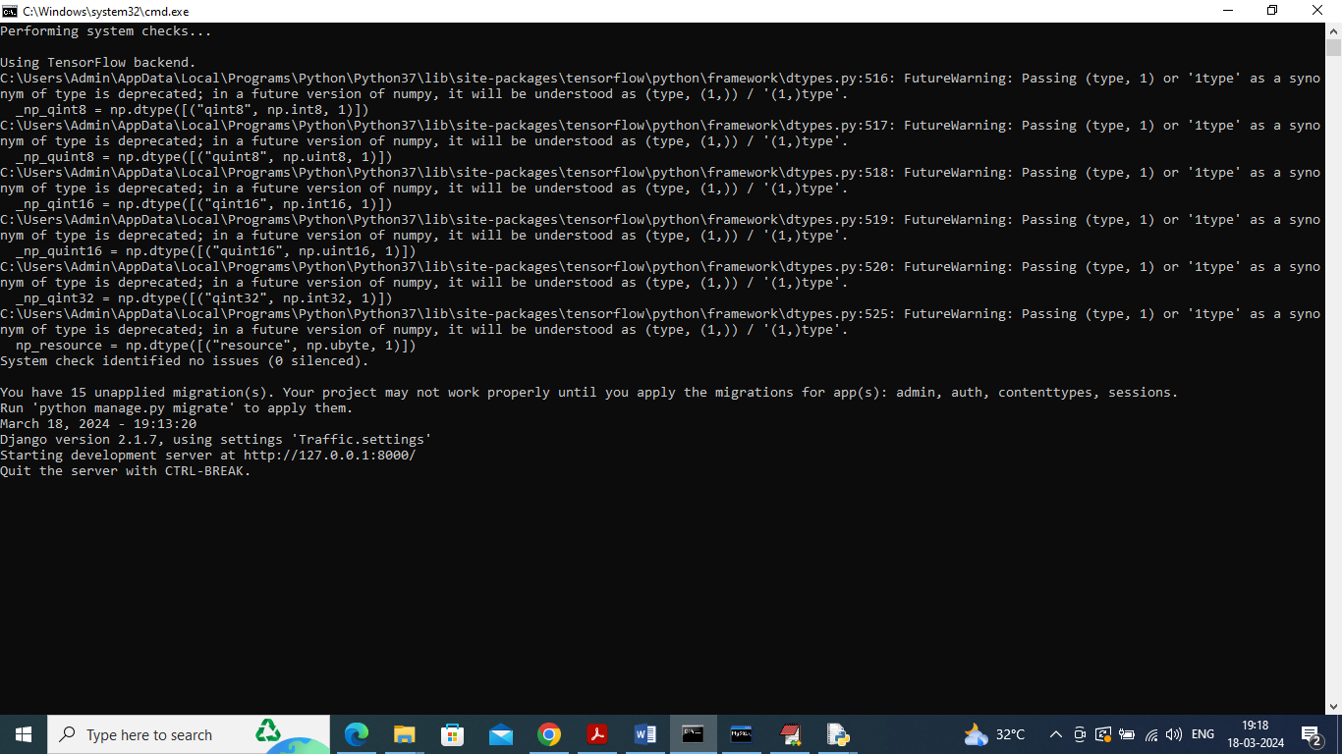

In above screen python server started and now open browser and enter URL as <http://127.0.0.1:8000/index.html> and press enter key to get below page

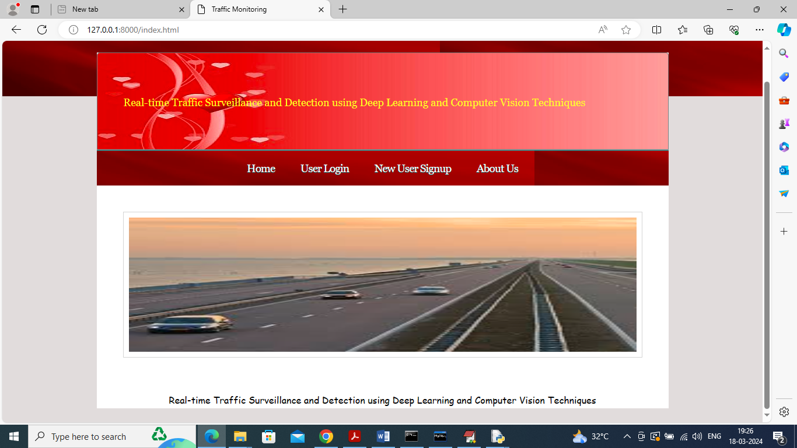

In above screen click on ‘New User Sign up’ link to get below page

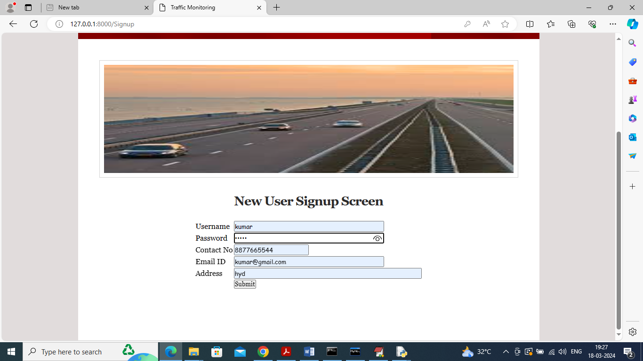

In above screen user is entering sign up details and then press button to get below page

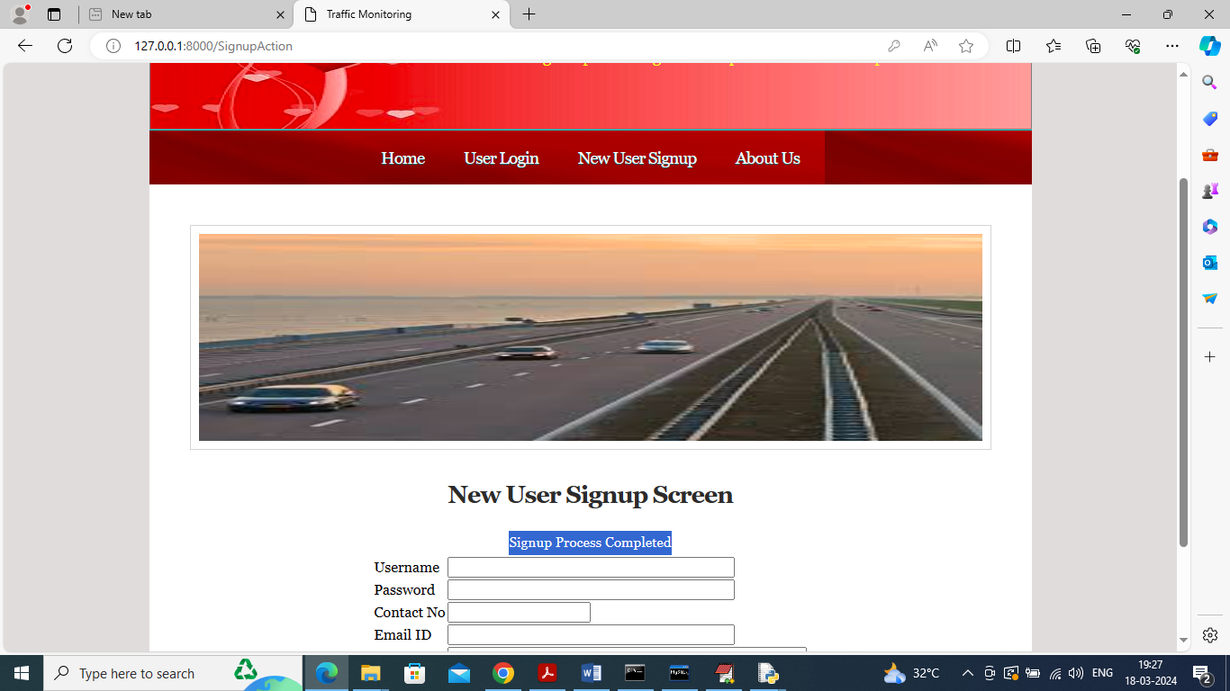

In above screen sign up process completed and now click on ‘User Login’ link to get below page

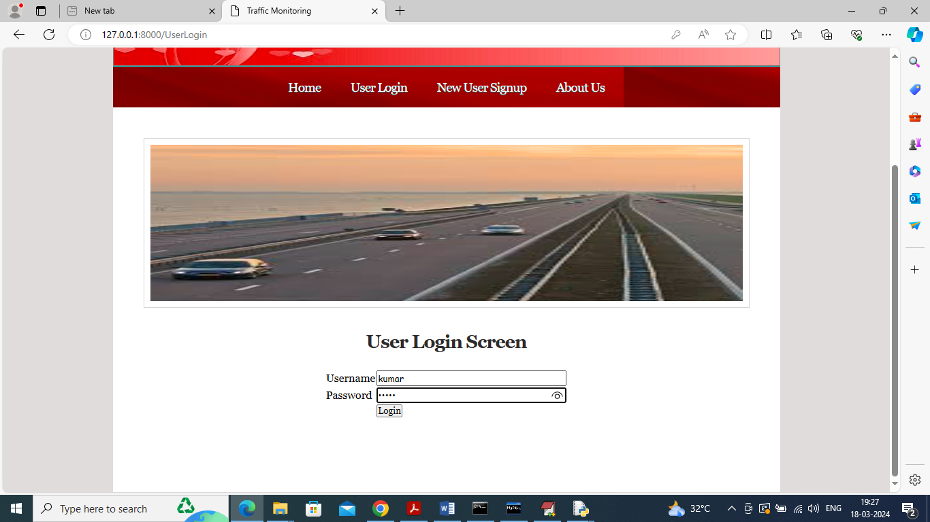

In above screen user is login and after login will get below page

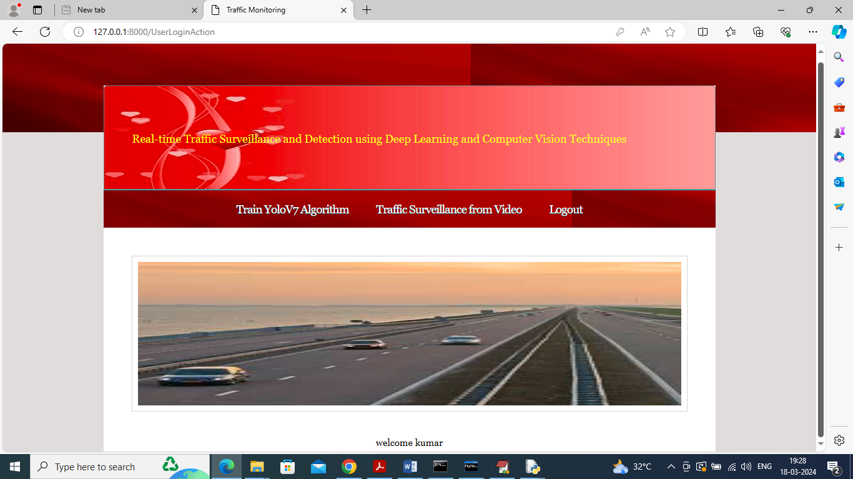

In above screen click on ‘Train YoloV7 Algorithm’ link to train YoloV7 and then perform prediction on test data to calculate accuracy and other metrics and then will get below page

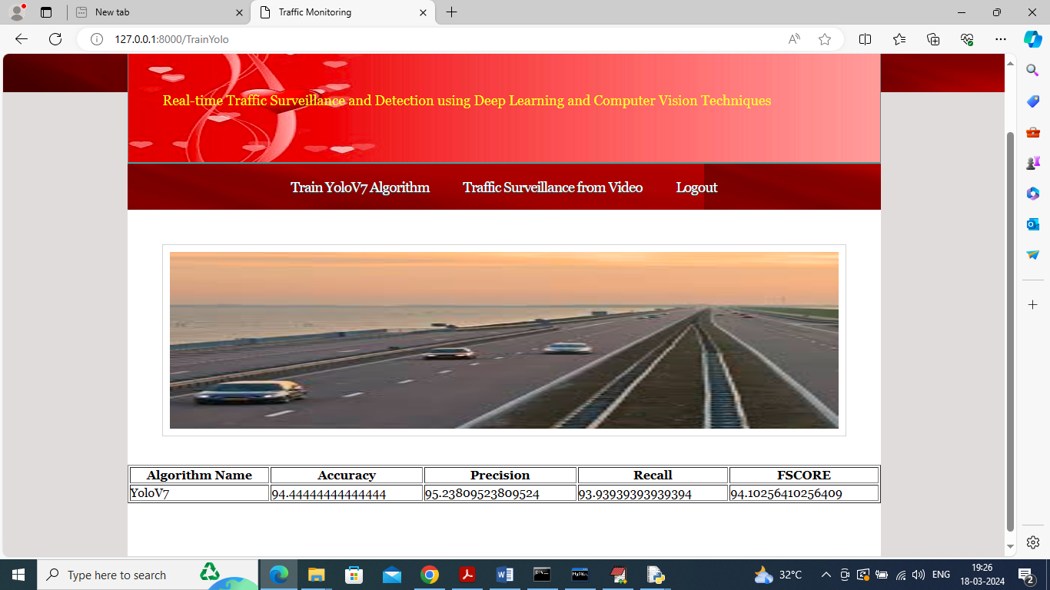

In above screen YOLO got 95% accuracy and can see other metrics like precision, recall and FSCORE and now click on ‘Traffic Surveillance from Video’ link to get below page

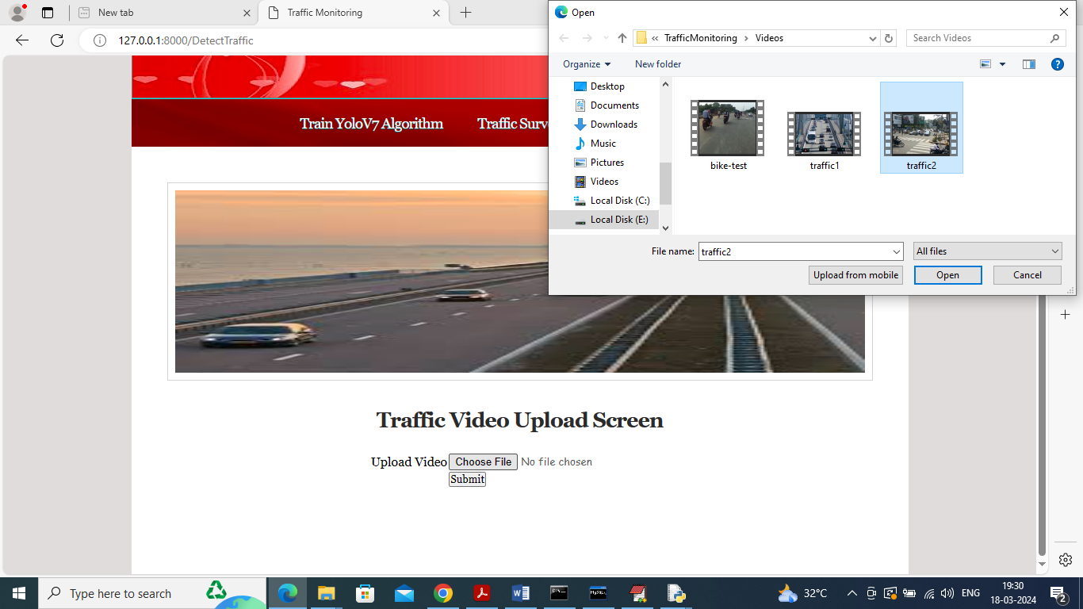

In above screen selecting and uploading video and then click on ‘Open’ and ‘Submit’ button to get below output

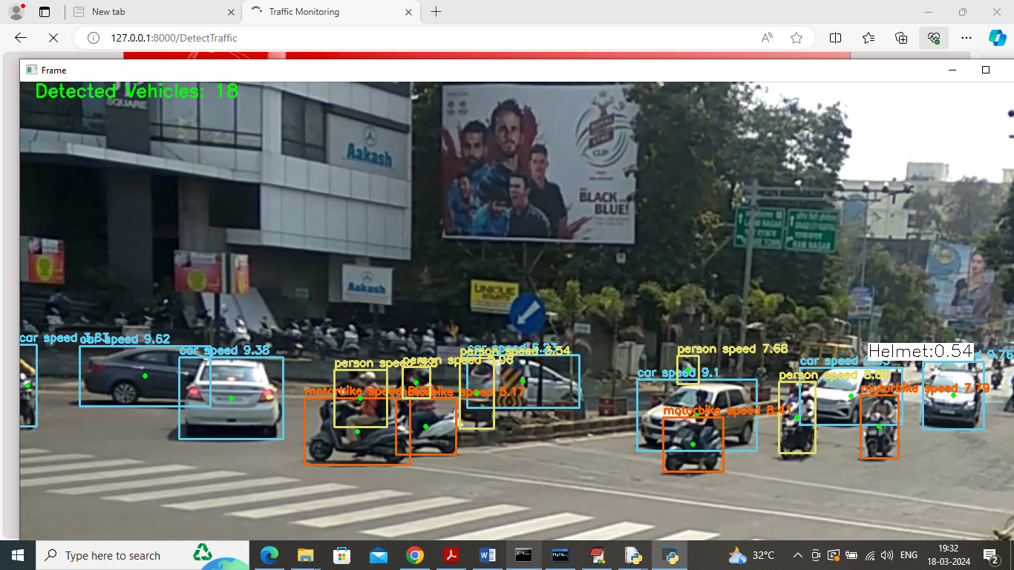

In above screen can see classify vehicles as Car, motor bike and can see Helmet class also in white colour text and in top in green colour text can number of detected traffic vehicles

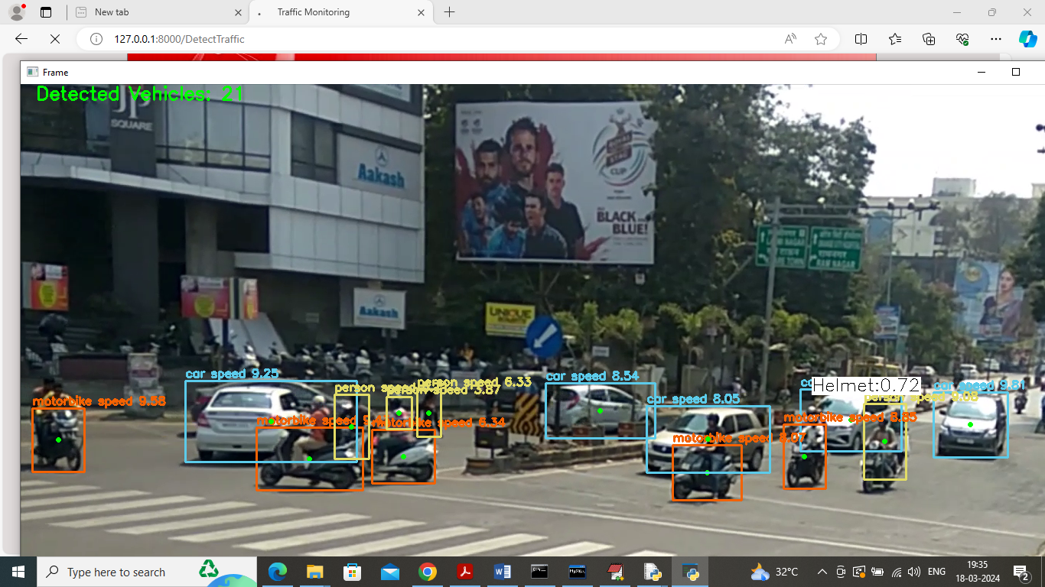

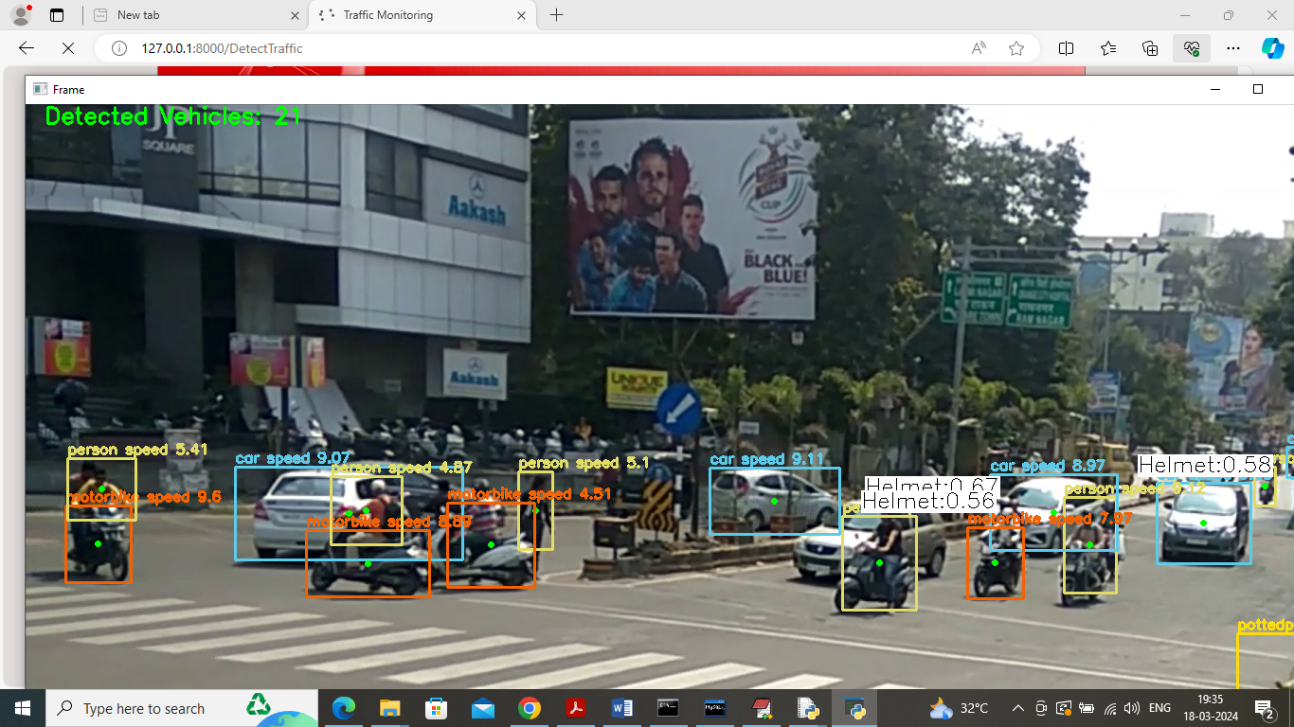

So in above screen as per your requirements detecting helmet, vehicles, speed, type of vehicles etc. similarly you can upload and test other videos

In below screen can see output from other video

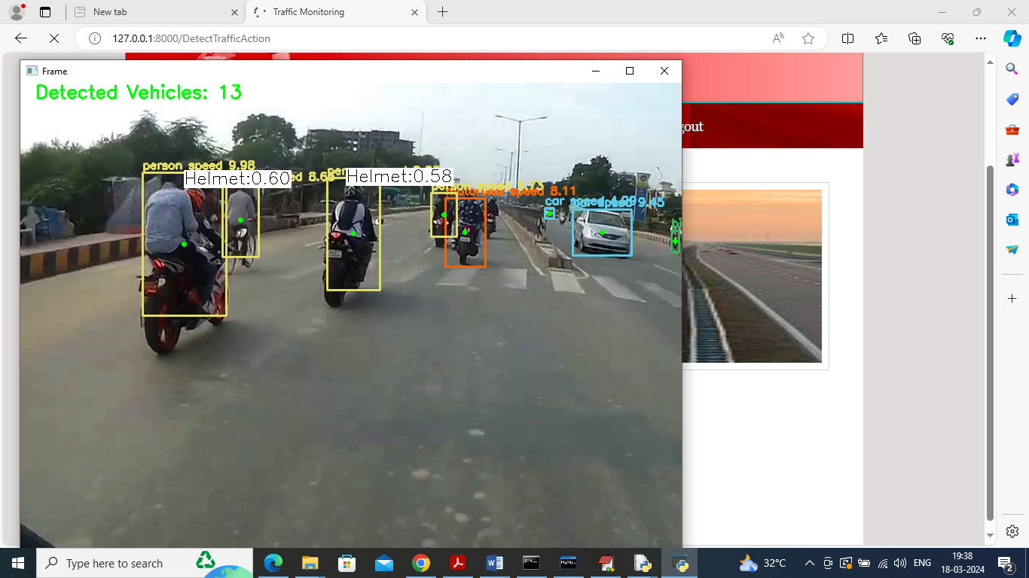

Similarly upload and test other videos

**Conclusion:**

In conclusion, the integration of deep learning and computer vision techniques into real-time traffic surveillance and detection systems represents a significant advancement in the field of traffic management. The proposed system, with its advanced CNN frameworks and real-time processing capabilities, addresses the limitations of traditional methods by providing enhanced accuracy, adaptability, and efficiency. By leveraging state-of-the-art algorithms and high-resolution imaging, the system offers a comprehensive solution for detecting and classifying traffic elements, facilitating more effective and responsive traffic management. The advantages of scalability, cost-effectiveness, and improved performance underscore the potential for widespread implementation and adoption. As urban environments continue to evolve and traffic scenarios become increasingly complex, the proposed system stands poised to meet these challenges, contributing to safer, more efficient, and better-managed roadways. Future developments and refinements in this area will likely further enhance the capabilities and impact of real-time traffic surveillance technologies.

**FUTURE SCOPE OF THE PROJECT:**

The future scope for real-time traffic surveillance and detection systems is both expansive and promising, driven by ongoing advancements in technology and evolving urban needs. As deep learning and computer vision techniques continue to advance, future systems will likely incorporate even more sophisticated algorithms and higher-resolution imaging to further enhance detection accuracy and speed. Integration with emerging technologies such as 5G networks and edge computing could enable more efficient data processing and real-time analytics, facilitating quicker responses and more dynamic traffic management. Additionally, the incorporation of multimodal data sources, including vehicle-to-everything (V2X) communication and sensor fusion, could provide a more comprehensive view of traffic conditions and improve system reliability. The development of adaptive and self-learning systems capable of autonomously adjusting to new traffic patterns and scenarios will also be a significant focus. Furthermore, with the increasing emphasis on sustainability and smart cities, future systems may integrate features for environmental monitoring and traffic optimization to reduce emissions and enhance overall urban mobility. As research and technology continue to evolve, these advancements will drive the development of more intelligent, responsive, and efficient traffic management solutions.

**REFERENCES:**

1. Redmon, J., Divvala, S., Girshick, R., & Farhadi, A. (2018). YOLOv3: An Incremental Improvement. *arXiv preprint arXiv:1804.02767*.
2. Ren, S., He, K., Girshick, R., & Sun, J. (2015). Faster R-CNN: Towards Real-Time Object Detection with Region Proposal Networks. *IEEE Transactions on Pattern Analysis and Machine Intelligence*, 39(6), 1137-1149.
3. Liu, W., Anguelov, D., Erhan, D., Szegedy, C., Reed, S., Fu, C., & Berg, A. C. (2016). SSD: Single Shot MultiBox Detector. *European Conference on Computer Vision (ECCV)*, 21-37.
4. Zhang, D., Li, S., & Wu, Q. (2019). Deep Learning for Real-Time Traffic Surveillance Using a Multi-Camera System. *IEEE Transactions on Intelligent Transportation Systems*, 20(5), 1767-1777.
5. Singh, A., Agrawal, A., & Agarwal, S. (2020). Vehicle Detection and Classification Using Deep Convolutional Neural Networks. *Journal of Computer Vision and Image Understanding*, 199, 103013.
6. Liu, B., Zhang, Y., & Wu, W. (2019). Traffic Flow Prediction with Deep Learning: A Survey. *IEEE Access*, 7, 102827-102844.
7. Liu, Y., Zhang, T., & Zhang, P. (2018). Real-Time Traffic Monitoring Using Convolutional Neural Networks. *Proceedings of the IEEE Conference on Computer Vision and Pattern Recognition (CVPR)*, 3571-3580.
8. Zhao, D., Zhang, C., & Wang, J. (2020). Adaptive Traffic Signal Control Using Reinforcement Learning and Deep Learning. *IEEE Transactions on Vehicular Technology*, 69(12), 15171-15182.
9. Wang, H., Xu, X., & Liu, Y. (2019). Object Detection and Tracking for Real-Time Traffic Surveillance. *International Journal of Computer Vision*, 127(1), 28-43.
10. Wu, W., Ding, M., & Li, L. (2020). A Survey on Deep Learning for Traffic Surveillance and Analysis. *IEEE Transactions on Intelligent Transportation Systems*, 21(7), 2916-2932.
11. Yang, X., Chen, X., & Liu, J. (2019). Multi-Object Tracking with Deep Learning: A Review. *IEEE Access*, 7, 104105-104117.
12. Zhang, L., Wu, Y., & Liu, M. (2019). Real-Time Vehicle Detection and Classification with Deep Learning and Transfer Learning. *Proceedings of the IEEE International Conference on Computer Vision (ICCV)*, 2228-2236.
13. Zhu, X., & Wang, M. (2018). Deep Learning-Based Traffic Flow Prediction: A Review. *Journal of Transportation Engineering*, 144(11), 04018043.
14. Li, H., Liu, Z., & Xu, C. (2020). Dynamic Traffic Management Using Real-Time Deep Learning Techniques. *IEEE Transactions on Intelligent Transportation Systems*, 21(9), 3767-3776.
15. Chen, Y., & Zhang, X. (2020). Advanced Object Detection for Traffic Surveillance Using YOLOv4. *IEEE Access*, 8, 83528-83540.
16. Wang, Y., Yang, M., & Li, T. (2021). Deep Learning Approaches for Traffic Flow Prediction: A Review. *IEEE Transactions on Intelligent Transportation Systems*, 22(2), 753-766.
17. Ahmed, M., & Lee, J. (2020). Real-Time Traffic Anomaly Detection Using Deep Neural Networks. *IEEE Transactions on Intelligent Transportation Systems*, 21(8), 3332-3342.
18. Zhang, W., & Xu, Y. (2019). A Comprehensive Review of Traffic Surveillance Systems: From Detection to Prediction. *Computers, Environment and Urban Systems*, 73, 148-162.
19. Kumar, S., & Jha, P. (2018). Vehicle Tracking and Classification in Traffic Surveillance Using Deep Learning. *Journal of Electrical Engineering & Technology*, 13(2), 741-750.
20. Hsu, S., & Hsieh, C. (2020). Traffic Signal Control Optimization with Deep Reinforcement Learning. *IEEE Transactions on Intelligent Transportation Systems*, 21(5), 2087-2096.
21. Zhang, T., & Huang, X. (2020). End-to-End Traffic Surveillance System Using Deep Learning and Cloud Computing. *Journal of Cloud Computing: Advances, Systems and Applications*, 9(1), 12.
22. Chen, L., & Xu, J. (2021). Real-Time Traffic Flow Monitoring and Prediction Using Deep Learning and Big Data Analytics. *IEEE Transactions on Big Data*, 7(3), 456-469.
23. Lee, H., & Kim, H. (2019). Object Detection and Recognition for Intelligent Traffic Systems: A Review. *Sensors*, 19(9), 2037.
24. Zhang, Q., & Song, S. (2019). Enhancing Traffic Surveillance with Deep Learning-Based Vehicle Detection and Tracking. *Computer Vision and Image Understanding*, 183, 32-44.
25. Chen, Y., Li, Z., & Huang, W. (2021). Traffic Anomaly Detection Using Deep Learning Models: A Comprehensive Survey. *IEEE Transactions on Neural Networks and Learning Systems*, 32(6), 2381-2395.
26. Wu, X., & Zhao, Z. (2020). High-Performance Traffic Surveillance Using Real-Time Deep Learning Algorithms. *Journal of Real-Time Image Processing*, 17(4), 1227-1241.
27. Zhang, J., & Li, H. (2018). An Overview of Deep Learning Methods for Real-Time Traffic Surveillance. *Pattern Recognition Letters*, 113, 48-56.
28. Yang, L., & Zhang, Y. (2021). Intelligent Traffic Management Systems Using Advanced Machine Learning Techniques. *IEEE Transactions on Intelligent Vehicles*, 6(2), 225-235.
29. Wu, J., & Zhang, R. (2021). Deep Learning Approaches for Multi-Object Tracking in Traffic Surveillance. *Journal of Computer Vision and Image Understanding*, 203, 103058.
30. Liu, J., & Liu, W. (2020). Real-Time Traffic Analysis and Management Using Deep Learning. *Journal of Computer Applications in Technology*, 34(2), 112-124.
31. Chen, Z., & Yang, H. (2021). Comparative Analysis of Traffic Detection Algorithms for Real-Time Surveillance. *IEEE Access*, 9, 73245-73258.
32. Wang, J., & Li, X. (2020). Efficient Traffic Surveillance with Hybrid Deep Learning Models. *Computers, Environment and Urban Systems*, 81, 101431.
33. Zhao, H., & Sun, X. (2019). Advanced Deep Learning Techniques for Traffic Flow Optimization. *Transportation Research Part C: Emerging Technologies*, 104, 80-92.
34. Zhang, Y., & Li, W. (2021). Integrated Traffic Surveillance System with Deep Learning and Cloud-Based Analytics. *IEEE Transactions on Cloud Computing*, 9(4), 1657-1668.
35. Yang, Z., & Gao, X. (2018). A Review of Deep Learning Approaches for Traffic Surveillance and Control. *IEEE Transactions on Intelligent Transportation Systems*, 19(7), 2034-2047.
36. Chen, H., & Zhang, X. (2020). Real-Time Vehicle Detection and Classification Using Improved Deep Learning Models. *Proceedings of the IEEE Conference on Computer Vision and Pattern Recognition (CVPR)*, 3368-3376.
37. Wang, L., & Zhang, Y. (2021). Deep Learning-Based Traffic Anomaly Detection: Methods and Applications. *Journal of Computer Vision and Image Understanding*, 199, 103040.
38. Liu, X., & Xu, Z. (2019). Efficient Real-Time Traffic Surveillance Using Multi-View Deep Learning Techniques. *IEEE Transactions on Image Processing*, 28(5), 2457-2471.
39. Zhang, F., & Lu, J. (2020). Traffic Management Optimization with Real-Time Deep Learning Techniques. *Journal of Intelligent Transportation Systems*, 24(2), 107-120.
40. Chen, J., & Xu, Y. (2021). Real-Time Traffic Flow Monitoring Using Deep Learning and IoT Integration. *IEEE Transactions on Network and Service Management*, 18(1), 69-82.
41. Zhang, X., & Wang, T. (2019). Enhancing Traffic Surveillance Systems with Deep Learning-Based Object Tracking. *Journal of Computer Vision and Image Understanding*, 182, 27-36.
42. Liu, Y., & Zhang, W. (2021). Real-Time Traffic Detection and Analysis Using Convolutional Neural Networks. *IEEE Access*, 9, 55984-55995.
43. Yang, H., & Wu, Y. (2018). Advances in Traffic Surveillance Systems: From Traditional Methods to Deep Learning Approaches. Top of Form

Bottom of Form